**Course Code: CSE2067**

**Course Title: Web Technologies**

**Lab sheet 10 - Module 3**

**Problem Statement:**

Write a PHP script with MYSQL to display the employee data for following criteria.

1. Create the database with Minimum 5 employee records like (Id(primary key), name, department and salary).
2. Create HTML page to search employee data using Id and Salary.

**Step 1: run XAMPP application with MySQL**

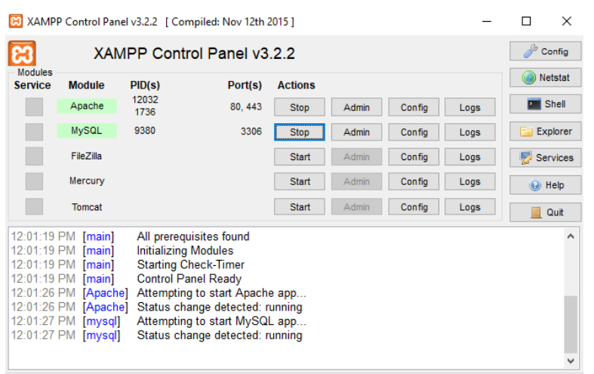

**Step 2: create a new php file filename.php and place the php file in C:/xampp / htdocs folder (accommodate required statements to establish connection with your database)**

***Search.html***

<!DOCTYPE html>

<html lang="en-us">

    <head> <title>Employee Details</title> </head>

    <body>

        <h1>Employee Details</h1>

        <form class="emp" action="http://localhost/dbdisplay.php" method="post">

        <br><h3>Search Employee Details Based on Employee ID</h3>

        <br>Enter Employee ID:<input type="number" id="Id" name="Id" >

        <br><br><input type="submit" value="Search" onclick="SaveEmpDetails()">

        </form>

        <form class="emp" action="http://localhost/dbdisplay.php" method="post">

            <br><h3>Search Employee Details Based on Salary</h3>

            <br>Enter Employee Salary Range:<input type="number" id="SS" name="SS" >

            Between

            <input type="number" id="LS" name="LS" >

            <br><br><input type="submit" value="Search" onclick="SaveEmpDetails()">

            </form>

    </body>

</html>

</body>

</html>

***Searchdb.php***

<?php

$servername = "localhost"; // default

$username = "root"; // root is a username

$password = "";     // No password for my db that why it is blank

$dbname = "Employee"; // mydb is my db name

// Create connection

$conn = mysqli_connect($servername, $username, $password, $dbname);

// Check connection

if (!$conn) {

  die("Connection failed: " . mysql_connect_error());

}

// Query Processing

if($_POST["Id"]!=0) // search using ID

{

$v1=$_POST["Id"];

$sql = "SELECT * from emp where Id=$v1";

}

else  // search using salary

{

  $v2=$_POST["SS"];

  $v3=$_POST["LS"];

  $sql = "SELECT * from emp where Salary between $v2 AND $v3";

}

$result = mysqli_query($conn, $sql); // conn for connection execute query

// Result processing

if (mysqli_num_rows($result) > 0)

{

  // output data of each row

  while($row = mysqli_fetch_array($result))

{

    print "Employee ID: " . $row["Id"]."<br><br>";

    print "Employee Name: " . $row["Name"]."<br><br>";

    print "Employee Department: " . $row["Dept"]."<br><br>";

    print "Employee Salary: " . $row["Salary"]."<br><br>";

    print "*********************" ."<br><br>";

  }

}

else

{

  echo "0 results";

}

mysqli_close($conn);// close the database

?>

**OUTPUT**

**Search from**

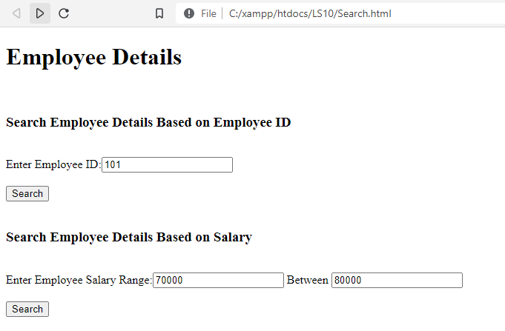

**Search using Employee ID**

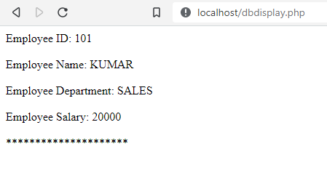

**Search using Employee Salary**

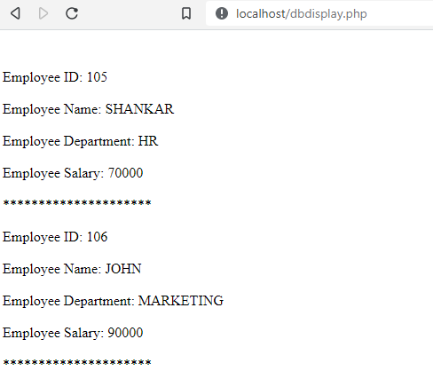

**Manually Create Employee Database table**

